**SPH3U 11.6 Kirchhoff’s Laws**

1. **Kirchhoff’s Laws**

|  |  |
| --- | --- |
| Kirchhoff’s Voltage Law (KVL): |  |
| series |  |
| parallel |  |

|  |  |
| --- | --- |
| Kirchoff’s Current Law (KCL): |  |
| series |  |
| parallel |  |

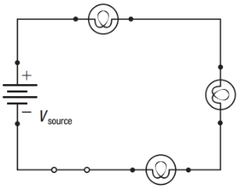If a 6.0 V battery with 0.20 A of current is connected to three identical light bulbs in series, what is the voltage and current of each light bulb?

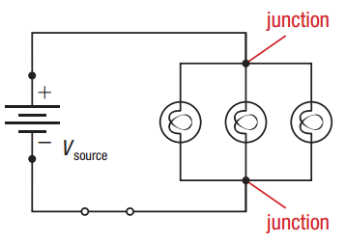If a 6.0 V battery with 0.30 A of current is connected to three identical light bulbs in parallel, what is the voltage and current of each light bulb?

Analyze this mixed circuit. Find each unknown voltage and current, given the following information: Vsource = 40 V, V1 = 10 V, V3= 20 V; Isource = 0.40 A, I3 = 0.10 A.

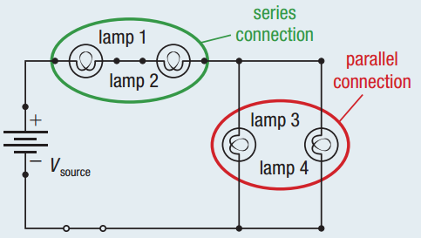

**Homework:** page 522: #1-2